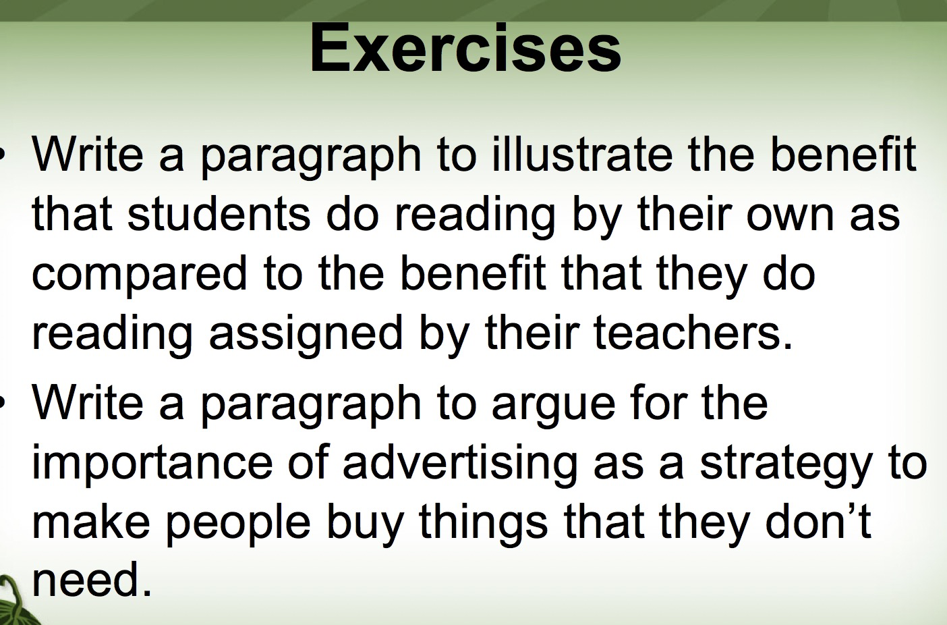

Students sometimes don’t know what to read or how to read. Teacher‘s guidance will definitely help them in this case. Teacher can list some useful books and give some key points to help students fully understand these complicated ideas. However, sometimes they just like explore freely. If students read material for curiosity, they will read for a longer time and have a deep understanding because they want to figure out their questions. For example, people who interest in history books don’t want to read the materials which is assigned by their teachers. Because they feel that they've got restrictions. In fact, interesting books can greatly motivate these students to seek knowledge.

Advertising can play an important role in motivating purchase. For example, everyday my mother watch videos by her mobile phone. So she can’t avoid to watch advertisement. Although she needn’t so many clothes, clothes advertisement usually appeal to her. She asks me whether she should buy this part of shoes or another part of shoes over and over again. It troubles me a lot. Study shows that once people watch an advertisement for a few seconds, they will imagine their wonderful life after buy this thing. In fact, most of us even don’t realize it. It proves that advertisement make a real difference in people’s shopping choice.

